IoT Community - Stream Deck Project

# Executive summary

This document specifies high-level detail and estimate costs involved in the design and implementation of an Arduino based Streaming Deck. Besides being an excellent learning opportunity for participants of the IoT community, this highly customizable device will be a great asset to enhance the communication experience of those employees who are currently working from home.

# Project Background

Across its two years of existence, the IoT Community was continually active and has organized multiple activities (DevWeek presentations, SmartRoom project for Innovation Lab, Hands on experiences, etc ) to engage the participation and contribute to create theorical and experimental expertise in this subject.

Sadly, the Covid-19 pandemic and the enforced need to work for home created a significant impact in the community that having a mixed approach between software and hardware, depended heavily on physical presence to share electronical components so every community member was able to participate on distinct stages of the project.

With that in mind, this project was designed to generate engagement in the community by building an artifact aimed to enhance the working experience during the multiple meeting calls implied by a distributed team.

# Project Details

The final artifact will be a Customizable Stream Deck Keypad with a LCD screen, two rotative encoders and 8 configurable buttons.

On its default mode, the keypad, can be used for meetings to easily mute/unmute the microphone or decrease/increase the volume. It could also be configured to send a sound notification to other devices, as well as open apps, execute a combination of keys to perform actions, like copy/paste, close apps, move between apps, etc.

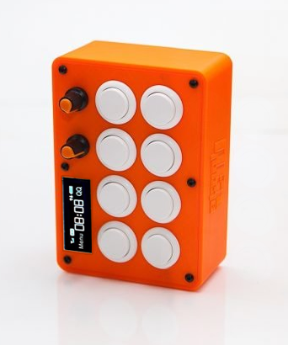

# Requirements and Components

The project will be implemented over an Arduino Pro Micro platform, with a 3D printed case, and standard arcade buttons, to simplify the process on its first iterations:

* 1 Case - $1600.-
* 1 Arduino Pro Micro - $680 ML
* 9 Arcade Buttons with Micro-switch 24mm – $1350.- ($150 *9)
* 1 Display Lcd 16x2 - $700 ML
* 2 Rotative Encoder - $400 ($200 *2)
* 2 Knob for encoder - $200
* Wire
* (Optional) 18 terminal connectors
* (Optional) 9 Leds for backlight
* (Optional) Buzzer

# Future plans

The device was designed to be as flexible as possible to enable member of the community to enhance and extends its functionality to accommodate future ideas and projects of the IoT community.